Chapter 6, Problem 30.

Assuming that the capacitors are initially uncharged, find
v_{o}(t) in the circuit in Fig. 6.62.

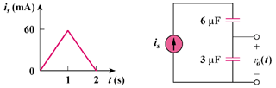
90

Figure 6.62
For Prob. 6.30.

